University Of Engineering and Technology, Lahore
Computer Engineering Department

Course Name: Programming Fundamentals | Course Code: CMPE-112L
Assignment Type: Lab Report | Dated:
Semester: 1st | Session: 2026 Spring
Lab/Project/Assignment #: 7 | CLOs to be covered: CLO
Lab Title: Sets | Teacher Name: Hafiz Muhammad Mubashar
Lab Evaluation:

CLO1 | Apply appropriate programming techniques to create executable programs to solve well defined problems
 | Level1 | Level2 | Level3 | Level4 | Level5 | Level6
(5)
Total |  |  |  |  |  | /5
Rubrics for Current Lab Evaluation
Scale | Marks | Level | Rubric
Excellent | 5 | L1 | Submitted all lab tasks, BONUS task, have good understanding.
Very Good | 4 | L2 | Submitted the lab tasks but have good understanding
Good | 3 | L3 | Submitted the lab tasks but have weak understanding.
Basic | 2 | L4 | Submitted the lab tasks but have no understanding.
Barely Acceptable | 1 | L5 | Submitted only one lab task.
Not Acceptable | 0 | L6 | Did not attempt
LAB No 1
Lab Goals/Objectives:
• Understand the concept of sets.
• Learn to create and use sets in Python
.
Equipment Required:
• Computer/Laptop
• Python 3.x
• IDE (IDLE, VS Code, or PyCharm)

Theory:

A set is an unordered collection of unique elements in Python. Sets are used to store distinct values and support operations such as union, intersection, difference, and membership testing. They are useful for removing duplicate values and performing mathematical set operations.

Lab Work:

Set:

Task 1:

s={}
a=type(s)
print(a)
print(s)
#{} is non-empty set it becomes dictionary

b=set()
type(b)
print(b)
# set() is actual empty set
# 0/0 or infinity/infinity is indeterminent form bcz they cant be defined

Result:
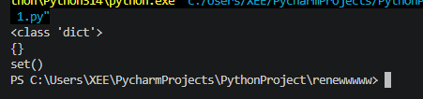

Task 2
s={1,2,3,"zainab"}
s.add("noor")
s.discard("zainab")
s.remove(1)
s.discard("ali")
print(s)
#unlike discard if we write something non-existing by remove it gives error

Result:
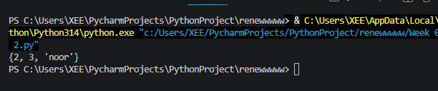

Task 3:
name={"noor","zainab","tayyaba","ayesha"}
for i in name:
user = input("enter your name:")
if user in name:
print("exist")
else:
print("not exist")

Result:
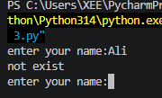

Task 4:
s={1,2,3,"zainab"}
s.pop()
print(s)
s.clear()
print(s)

Result:
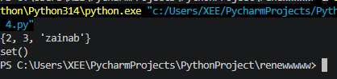

Task 5:
s1={1,2,3}
s2={4,5,6}
s3={7,8,9}
b=set.union(s1,s2,s3)
print(b)

Result:

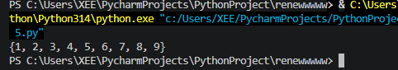

Task 6:
s1={1,2,3}
s2={4,5,6}
s3={7,8,9}
s2.update(s3)
s1.update(s2)

print(s1)
print(s2)
print(s3)
Result:
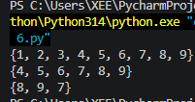

Task 7:
s1={1,2,3}
s2={4,2,6}
s3={7,2,9}
b=set.intersection(s1,s2,s3)
print(b)
c=s1.intersection_update(s1,s2,s3)
print(c)
Result:
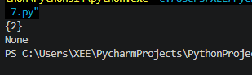

Task 8:
s1={1,2,3}
s2={4,2,6}
b=set.isdisjoint(s1,s2)
print(b)

Result:
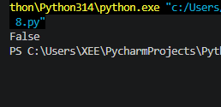

Task 9:
s1={1,2,3}
s2={4,2,6}
b=s1.issubset(s2)
print(b)

Result:
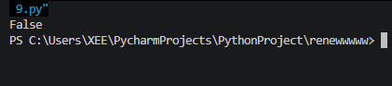

Task 10:
s1={1,2,3}
s2={4,2,6}
b=set.symmetric_difference(s1,s2)
print(b)

Result:
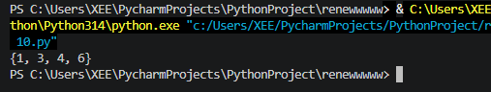

Task 11:
s={1,2,2,3}
a={"ali","ali"}
print(a)
print(s)
b=set([1,2,3,7])
print(b)

Result:

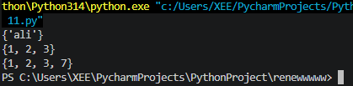

Conclusions:

In this lab, we learned how to create and use sets in Python. We also practiced basic set operations and understood how sets help manage unique data efficiently.

